
BEMU Sketch
Drafting

When you open the sketch tab, it is automatically in drafting mode. All envelope components are created in drafting mode (currently only the walls and cornerstone). To begin drawing a wall, click on the grid where you want to begin drawing.
Navigation
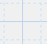
The grid is 160 ft x 160 ft composed of larger squares which are 10 ft x 10 ft and the smaller squares which are 2 ft x 2 ft. When drawing walls, the cursor will snap to points that are at 1 ft increments. This limitation can be expanded in precision mode (discussed later).
To move the canvas, click and drag the grid. To zoom, use the zoom buttons or when using a desktop, you can zoom with the scroll wheel.
Drawing
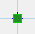
The cornerstone – the start point for your drawing - will be created when you first click on the grid. If you want to place your cornerstone in a different location, select it and press the delete button (or delete on your keyboard). You will not be able to change the cornerstone location once you begin drawing walls.
The sketch canvas is set to pan when it is touched and dragged which prevents drawing and the setting of the cornerstone – as best you can, ensure you do not drag the canvas when trying to set your point.

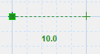
Walls can be drawn in a number of different ways. With the cornerstone drawn, if you click on the grid, a leader line with a green cursor will be displayed showing the proposed line and length. Press Enter (alternatively the left Ctrl key) on your keyboard or the equals’ button to draw the wall. Select somewhere else on the grid if you want a different wall.
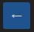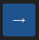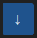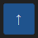 Alternately, with the cornerstone drawn, enter the desired length on the number pad and press an arrow button to indicate the direction for the wall to be drawn – fractional/decimal point lengths can be entered in this way. This method may be easier to execute while using a tablet in the field during data collection.
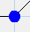
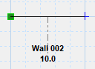
A blue cursor will appear at the end of the new wall – this is the drawing point for the next wall. The drawing point can be changed by selecting a different node at the end of any wall. For the completed drawing, all walls should be contiguous and result in an enclosed polygon.


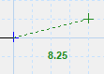
Angled walls can be drawn freehand by selecting a point on the grid and this may suffice in some instances, but to draw a precise angled wall, first click on the precision button. Enter the length for one direction and press the directional arrow. Enter the length for the second direction and press the corresponding directional arrow. The green arrow and cursor will follow the directions cumulatively. When you have finished entering directions draw the wall by pressing the equals’ button or Enter. Note: probably best to try this rather than trying to understand the directions.
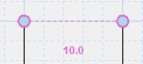
A final enclosing wall can only be drawn by indicating the nodes that should be joined. Select the node at the end of one wall, select the node that you want to join. The leader line and length indicator will turn a light pink to show that you are about to join the lines.
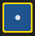 In the field, using a tablet, it can be difficult to select individual nodes (especially problematic when trying to join walls. To exposed all the nodes, use this button below the directional arrows

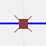
You can divide a wall by clicking on a wall to select it. Along the wall, a red box will appear at the proposed division point. Click on the red box and an “X” will appear and the length of the new proposed line will be shown in the number pad. If you are satified with the length, click the divide button. The proposed length can also be adjusted in the number pad for a more precise division.

Walls, connecting nodes or markup items can be deleted by selecting the object and pressing the delete button. If you delete a node connecting two walls, the walls are joined into one wall. A node cannot be deleted if it is connecting more than two walls (the respective walls should be deleted first). Deleting a wall in between walls may create an unenclosed area.
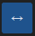
A node may be moved by selecting the node and indicating the new position then pressing the move button. For a precise move, select the precision button, select the node, enter the distance to move the node and then the direction arrow (additional moves can be included), press the move button. To move any label or text item, select the text and select a new position on the grid (pressing the move button is not needed).
Markup
[To be expanded]

Markup is fairly self explanatory. You can insert lines, polygons and text. Colors can be adjusted as required. When working with markup objects, you are no longer in drafting mode and cannot accidentally interact with walls or other envelope components – likewise when you are in markup mode, you cannot interact with drafting/envelope objects. To deform or change the shape of a line or polygon, select/click on an object node and click on the screen where you want the new node. Similarly, to move text, select the text and click the new location. Select any of the markup objects to adjust properties such as colors, line thicknesses, arrow ends or font size. When a line or polygon is created, you can continue to modify the object without having to reselect it. To modify a text item after it is initially created, you must reselect it. After modifying a text object, click on it to deselect and avoid accidentally moving the text to another location. To add a dimensional component to text, input the desired dimension in the number pad before creating the item or during modification, but in this latter case, the text value must be reselected to add the dimension.

Settings and Levels
The settings button allows you to show or hide the markup objects when you are working on multiple levels, to hide the envelope calculations or print the sketch (printing of the sketch not yet available). Once you are satisfied with your footprint, you can copy the walls onto the Foundation, Main, Upper and Third levels – this option becomes available when you change the level selector at the bottom of the canvas. The footprint outline is visible under the walls on the house levels to assist when modifying the wall configuration. On the levels other than the Footprint, you can modify the wall height and wall thickness through the settings button.
Calculations
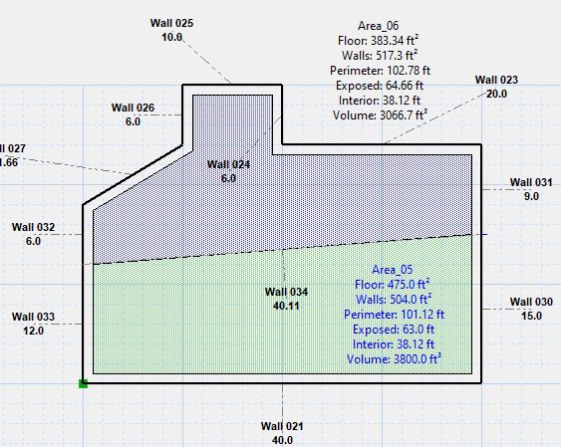

Use the calculate button to generate the dimension details for each level (note: floor areas are not calculated for the footprint and so nothing new is displayed on that level. The dimensions are calculated utilizing the wall height and wall thickness (which can be adjusted in the settings). The calculations should increase efficiency in determining walkout basements or exposed floors. [future versions will also summarize the floor areas and other details for each level]
[At this time, sloped ceiling calculations are not available, but the building blocks are there and they just need to be incorporated. As well, in future, wall groupings will be possible to allow for varying wall thicknesses as in the case of walkouts or additions.]
Appendix A: Text Objects
I have included acronym text objects for commonly used items (see definitions below) – I welcome feedback on these acronyms and what could be changed or added. Some long form text such as Basement, Crawlspace, Uninsulated and so forth can be selected from the dropdown list. A dimensional component can be added to either the long form, the acronyms or a custom label.
BCH | Basement Ceiling Height | MCH | Main Ceiling Height
UCH | Upper Ceiling Height | TCH | Third Ceiling Height
RH | Ridge Height | WH | Wall Height
AG | Above Ground | PW | Pony Wall
ID | Internal Dimension | ExF | Exposed Floor
SKY | Skylight | + | Custom

